Parkland Airport

Noise Sensitive Areas and Noise Abatement

When operating in the vicinity of the airport please be aware of the noise sensitive areas to the North which lie directly beneath a standard downwind.
Unless required otherwise, avoid flight over this area. If the flight over this area is necessary, only use a low power setting of 2100RPM.

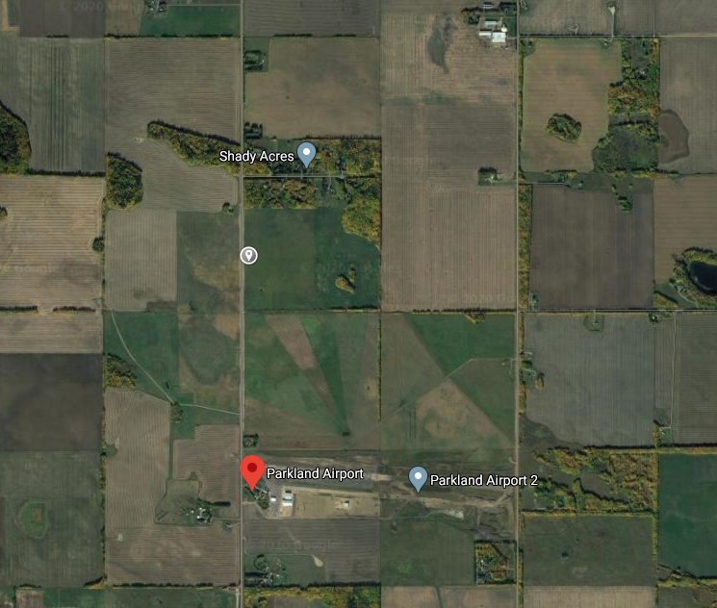
Noise Sensitive
Area
1NM Downwind Track

